Bidirectional LSTM in NLP

Introduction:
LSTM networks are a type of RNN architecture designed to overcome the vanishing gradient problem. They accomplish this by introducing memory cells and gates to control the flow of information. The input gate, forget gate, and output gate are three gates that control how information enters and exits the memory cell.
Bidirectional LSTM:
Bidirectional LSTMs process input sequences in both forward and backward directions at the same time, as opposed to typical RNNs, which process them in only one direction (from beginning to end).
The primary idea underlying bidirectional LSTMs is to capture both the preceding and subsequent contexts for each point in a sequence. This enables the model to better grasp and record relationships in both directions, potentially leading to enhanced performance in tasks requiring context from both past and future data.
Architecture:
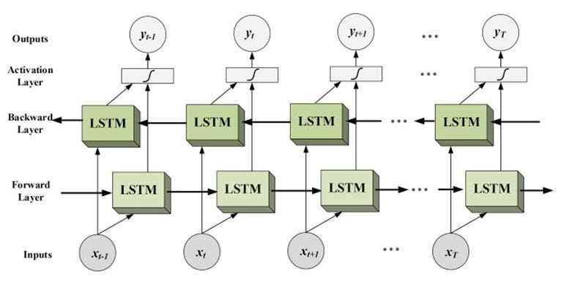
- Forward layer : This LSTM processes the input sequence from the beginning to the end, capturing information about the past context at each time step.
- Backward layer : This LSTM processes the input sequence from the end to the beginning, capturing information about the future context at each time step.
- Activation layer : The outputs from both the forward and backward LSTMs are usually combined in some way, such as concatenating them or averaging them, to create the final representation for each time step.

In a Bidirectional LSTM (BiLSTM), the **reverse time direction** refers to processing the input sequence backward, starting from the last element and moving towards the first.

- **Forward Time Direction**: This is the usual sequence processing, where the LSTM goes through the input from the first time step to the last. For example, the sequence is processed as: `x1, x2, x3, ..., xT` where `x1` is the input at the first time step, and `xT` is the input at the last time step.

- **Reverse Time Direction**: In addition to the forward processing, a BiLSTM has another LSTM that processes the input sequence in the opposite direction, starting from the last time step and moving to the first. The reverse order is: `xT, x(T-1), x(T-2), ..., x1`.

The purpose of the reverse time direction is to capture information from both the past and future within the sequence. This helps in tasks were knowing both the previous and upcoming data points is useful for making better predictions.
In a BiLSTM, you have two LSTM networks:
- One processes the sequence forward (left to right).
- The other processes the sequence backward (right to left).
Why Reverse Time Direction?
The idea behind processing in both forward and reverse directions is to capture context from both past and future time steps. A forward LSTM only captures the past information up to the current time step, but in many tasks (like natural language processing or time series), it’s also useful to know what happens after the current time step. The reverse LSTM helps with this by looking at the sequence backward, thereby learning patterns from future events relative to the current time step.
Example:
In a sentence like "The cat is sitting on the mat," knowing both the words before and after a particular word (like "sitting") can help in understanding its meaning. A BiLSTM can leverage both the past (what came before "sitting") and the future (what comes after "sitting") to make more accurate predictions or decisions.
Let’s say we have the following sentence: “The movie was great and I really enjoyed it!”
- Tokenization: First, we tokenize the sentence into individual words: [“The”, “movie”, “was”, “great”, “and”, “I”, “really”, “enjoyed”, “it”, “!”].
- Word Embedding: Each word is then converted into a vector representation using pre-trained word embeddings.
Example : “great” might be represented as [0.8, 0.2, -0.5, …], “enjoyed” might be represented as [0.7, 0.4, -0.6, …] .
3. Input Encoding: The word embeddings are fed into the LSTM layer. Each word embedding represents a time step in the sequence. For our example, imagine a bidirectional LSTM with a hidden size of two.
4. Forward Pass: The LSTM processes the input sequence in a forward direction, updating its hidden state at each time step using the current input and the prior hidden state. For example:
- At time step 1 (word “The”), the LSTM changes its hidden state using the embedding of “The” and the starting hidden state.
- At time step 2 (word “movie”), the hidden state is updated again using the “movie” embedding and the previously updated hidden state.
This process will continue until the final word in the sequence is handled.
5. Backward Pass: The LSTM processes the input sequence both forward and backward at the same time. This includes dependencies from the future context.
- At time step 9 (word “!”), the LSTM updates its hidden state in reverse using the embedding of “!” and the starting hidden state.
- It then goes backward, updating the concealed state with each time step until it reaches the start of the sequence.
6. Combining Outputs: The outputs from both the forward and backward passes are combined in some way (e.g., concatenation, averaging) to create the final representation for each time step.
7. Task-Specific Layer: The final representations are passed through a task-specific layer, such as a softmax..,
Advantages:
- Capturing Bidirectional Context: By processing the sequence in both forward and backward directions simultaneously, bidirectional LSTMs can potentially better understand the dependencies and relationships within the sequence, leading to improved performance in tasks that require understanding context from both directions.
- Long-range Dependency Handling: By considering both past and future context, bidirectional LSTMs can better capture these long-range dependencies, making them suitable for tasks with complex dependencies.
Disadvantages:
- Memory Requirements: Bidirectional LSTMs store hidden states for both forward and backward passes, which increases the memory requirements of the model.
- Increased Computational Complexity: Bidirectional LSTMs require processing the input sequence in both forward and backward directions simultaneously. As a result, training and inference with bidirectional LSTMs can be more computationally expensive and time-consuming, especially for large datasets and complex models.

